Documentation of US_county_Pop.dta
- Cases, time and variables
The data focus on demographic structure, such as proportion of male, proportion of age group and proportion of race group, of 3,142 counties from 2010 to 2018 yearly (estimated on July 1 in the year). There are 3,142×9 =28,278 county-year observations and 32 variables in data. A brief description of the variables is shown as below:
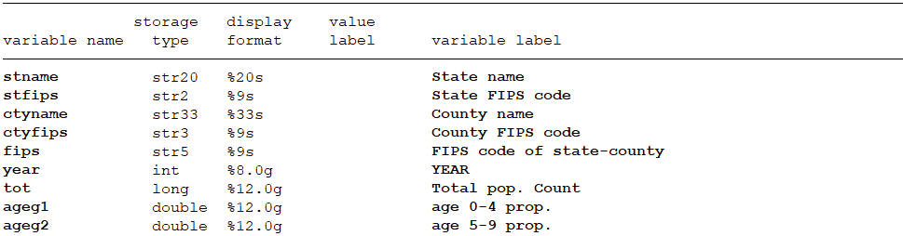
……
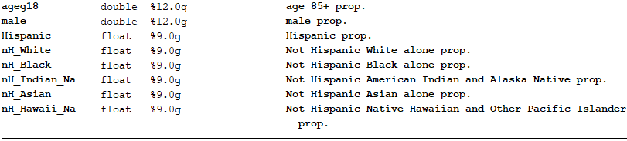

- Data source
Raw tables used to generate our data can download from:
https://www.census.gov/content/census/en/data/tables/time-series/demo/popest/2010s-counties-detail.html
When open this website, download series tables and documentation cc-est2018-alldata.pdf under:
Annual County Resident Population Estimates by Age, Sex, Race, and Hispanic Origin: April 1, 2010 to July 1, 2018 (CC-EST2018-ALLDATA)

- Structure of raw tables
There are 51seperated raw tables (one table for one state), and there is name and FIPS code of states or counties, and other demographic statistics. Raw tables are organized as follow:
CTYNAME | YEAR | AGEGRP | TOT_POP | TOT_MALE | TOT_FEMALE
Hawaii County | 1 | 0 | 185079 | 92821 | 92258
Hawaii County | 1 | 1 | 11845 | 6037 | 5808
Hawaii County | 1 | 2 | 11478 | 5945 | 5533
Hawaii County | 1 | …… | …… | …… | ……
Hawaii County | 1 | 18 | 3603 | 1380 | 2223
Hawaii County | 2 | 0 | 185076 | 92819 | 92257
Hawaii County | 2 | 1 | 11845 | 6037 | 5808
Hawaii County | 2 | 2 | 11478 | 5945 | 5533
Hawaii County | 2 | …… | …… | …… | ……
Hawaii County | 2 | 18 | 3603 | 1380 | 2223

- Procedures
Merge 51 files together at first and then start data construction procedure.
First, Get unique 5-digit FIPS code for each county.
Second, select one statistic from three 2010 estimate and record year.
1 = 4/1/2010 Census population
2 = 4/1/2010 population estimates base
3 = 7/1/2010 population estimate √
Third, reshape and get total number of age groups, sum up total number of race group.
Fourth, calculate percent of each demographic group.

